H.T No
Regulations:
A18

Sreenidhi Institute of Science and Technology
(An Autonomous Institution)
Code No: 7K717 Date: 11-July-2023 (AN)

B.Tech IV-Year I- Semester External Examination, July - 2023 (Supplementary)
FINITE ELEMENT METHOD FOR CIVIL ENGINEERS (CIVIL)

Time: 3 Hours Max.Marks:70

Note: a) No additional answer sheets will be provided.
b) All sub-parts of a question must be answered at one place only, otherwise it will not be valued.
c) Missing data can be assumed suitably.

Bloom's Cognitive Levels of Learning (BCLL)

Remember | L1 | Apply | L3 | Evaluate | L5
Understand | L2 | Analyze | L4 | Create | L6

Part - A Max.Marks:20
Answer all QUESTIONS

 |  | BCLL | CO(s) | Marks
1 | What is the principle of finite element method? | L1 | CO1 | [2M]
2 | What are the properties of stiffness matrix? | L1 | CO2 | [2M]
3 | Write the shape function for constant strain triangle by using polynomial function? | L1 | CO3 | [2M]
4 | Explain the isoparametric elements and its types. | L2 | CO4 | [2M]
5 | What is static condensation? | L2 | CO5 | [2M]
6 | List out different modules of ANSYS. | L2 | CO6 | [2M]
7 | Explain the concept of potential energy principle. | L1 | CO1 | [2M]
8 | List some disadvantages of using 3-D elements. | L1 | CO4 | [2M]
9 | Explain two point Gaussian Quadrature. | L2 | CO5 | [2M]
10 | What are the properties of shape functions? | L1 | CO2 | [2M]
Part – B Max.Marks:50
ANSWER ANY FIVE QUESTIONS. EACH QUESTION CARRIES 10 MARKS.

 |  |  | BCLL | CO(s) | Marks
11. |  | Find out deflection at centre of a simply supported beam of span length (L) subjected to uniformly distributed load throughout its length of intensity w per unit length. Use Rayleigh Ritz method. Take EI is constant | L3 | CO1 | [10M]
12. |  | Determine nodal displacement , element stresses and support reactions of the axially loaded bar as shown in fig  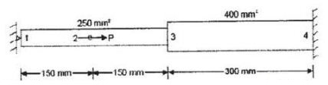 | L3 | CO2 | [10M]
13. |  | Evaluate the shape functions N1, N2 and N3 at the interior point P for the triangular element shown in the figure below.  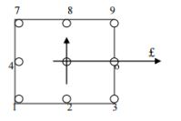 | L4 | CO3 | [10M]
14. |  | Evaluate the Jacobian matrix at the local co-ordinates ζ, η are (0, 0) for the element shown in the below  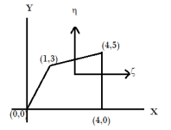 | L4 | CO4 | [10M]
15. |  | Solve for U3, U4 from the below equation using static condensation technique  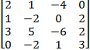 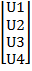 = | L3 | CO5 | [10M]
16. |  | Explain the procedure for solving a structural problem using ANSYS software | L2 | CO6 | [10M]
17. | a) | Derive shape functions for a 2D beam element. | L6 | CO1 | [5M]
 | b) | Derive the strain-displacement matrix (B-matrix) for plane stress analysis of three node triangular element | L5 | CO2 | [5M]
18. | a) | Obtain the shape functions for a quadrilateral element. | L5 | CO4 | [5M]
 | b) | Derive the element stiffness matrix for a four noded isoparametric plan stress element | L6 | CO5 | [5M]

-- 00 -- 00 –

